
ОБЩЕСТВО С ОГРАНИЧЕННОЙ ОТВЕТСТВЕННОСТЬЮ
«ЛАЗЕРТАГ»

ПАСПОРТ

Смоленск
LIMITED LIABILITY COMPANY
LASERWAR

SPECIFICATION

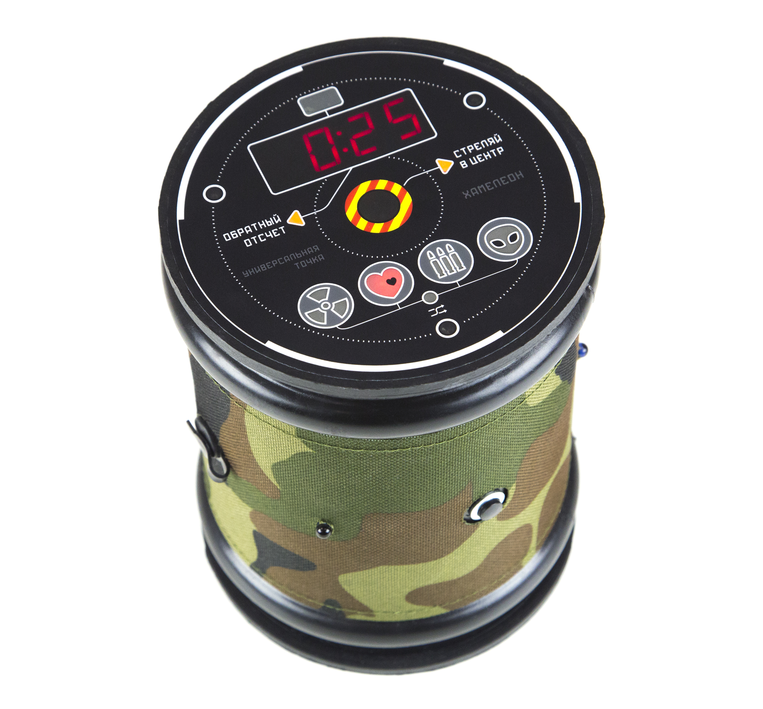

CHAMELEON universal point

Additional Device

Dear Customer!

Thank you for choosing our products! LLC LASERWAR would like to assure you that you will enjoy the purchased device and it will serve you long. This slip defines the terms of the warrantee as defined by the law of the Russian Federation “About consumers’ rights protection”.
This warrantee slip is valid for a period of 12 months from the purchase date provided that the terms and conditions set out in this warrantee are complied with.

7. Contact details
Official website:
www.laserwar.ru

e-mail:
info@laserwar.com
help@laserwar.com
Purchase date: _______________
Skype:
info@laserwar.com
help@laserwar.com

_____________________
signature

2
11
- Purpose
The Chameleon universal point play set is an additional device that is used for playing laser tag.

- Technical specifications
Weight | 0.620 kg
Height | 165mm
Base diameter | 125 mm
Number of infrared diodes | 6
Accumulator type | Li;  7.4 V; 2200 mAh
Battery charger type | Automatic, Li+
Continuous operation time | Up to 36 hours

- Delivery set
№ | Name | Unit type | Amount
1. | Universal point | pcs. | 1
2. | Product specification | pcs. | 1

Information about maintenance works during the warrantee period (filled out by a repair centre):

Date:__________________  Maintenance carried out: _____________________________________________________________________  Repair centre stamp | Date:__________________  Maintenance carried out: _____________________________________________________________________  Repair centre stamp
Date:__________________  Maintenance carried out: _____________________________________________________________________  Repair centre stamp | Date:__________________  Maintenance carried out: _____________________________________________________________________  Repair centre stamp
Date:__________________  Maintenance carried out: _____________________________________________________________________  Repair centre stamp | Date:__________________  Maintenance carried out: _____________________________________________________________________  Repair centre stamp

3
10
Warrantee terms and conditions:

1. The warrantee comes into force upon presenting of this slip, with a confirmed by a repair centre date of purchase displayed on it.
2. This warrantee only covers the devices purchased from an official representative of LLC LASERWAR, or its official dealer.
3. This warrantee does not cover product defects that resulted from:
- the customer not complying with the directions outlined in the User’s manual;
- physical damage;
- any objects or liquids getting inside the device;
- damage by animals;
- unauthorized access to the units and details of the device;
- abuse or misuse, including failure to use this product for its normal purposes;
- any cause beyond the control of the company, Force Majeure (natural catastrophes, fire, accidents, etc.);
- device failure due to being incorrectly connected, voltage fluctuations, and/or improper care.
4. Should it happen that you lose your warrantee slip, you will not be issued a copy.

- Description and operation
  - Construction
The cylinder shaped body of Chameleon universal point is made from black impact resistant plastic. At the top of the gadget, there is a digital display, Ammo, Health, Radiation and Anomaly signs, 3 infrared diodes and 1 infrared sensor. There are 3 infrared diodes, an advance security switch lock, a control button and a charger inlet on the body. The latter has an attached rubber cap.
The universal point supports 4 types of impulses: “radiation” (takes players’ lives away), “treatment” (fully restores heals, like a first aid kit), “ammo top-up” (tops up ammunition) and “anomaly” (organizers can choose any over 20 commands by a laser tag configurator).
The parameters of 3 types of scenarios can be edited in the admin mode or by a laser tag configurator.
The construction of the Chameleon universal point is presented in picture 1.

4
9
Picture 1

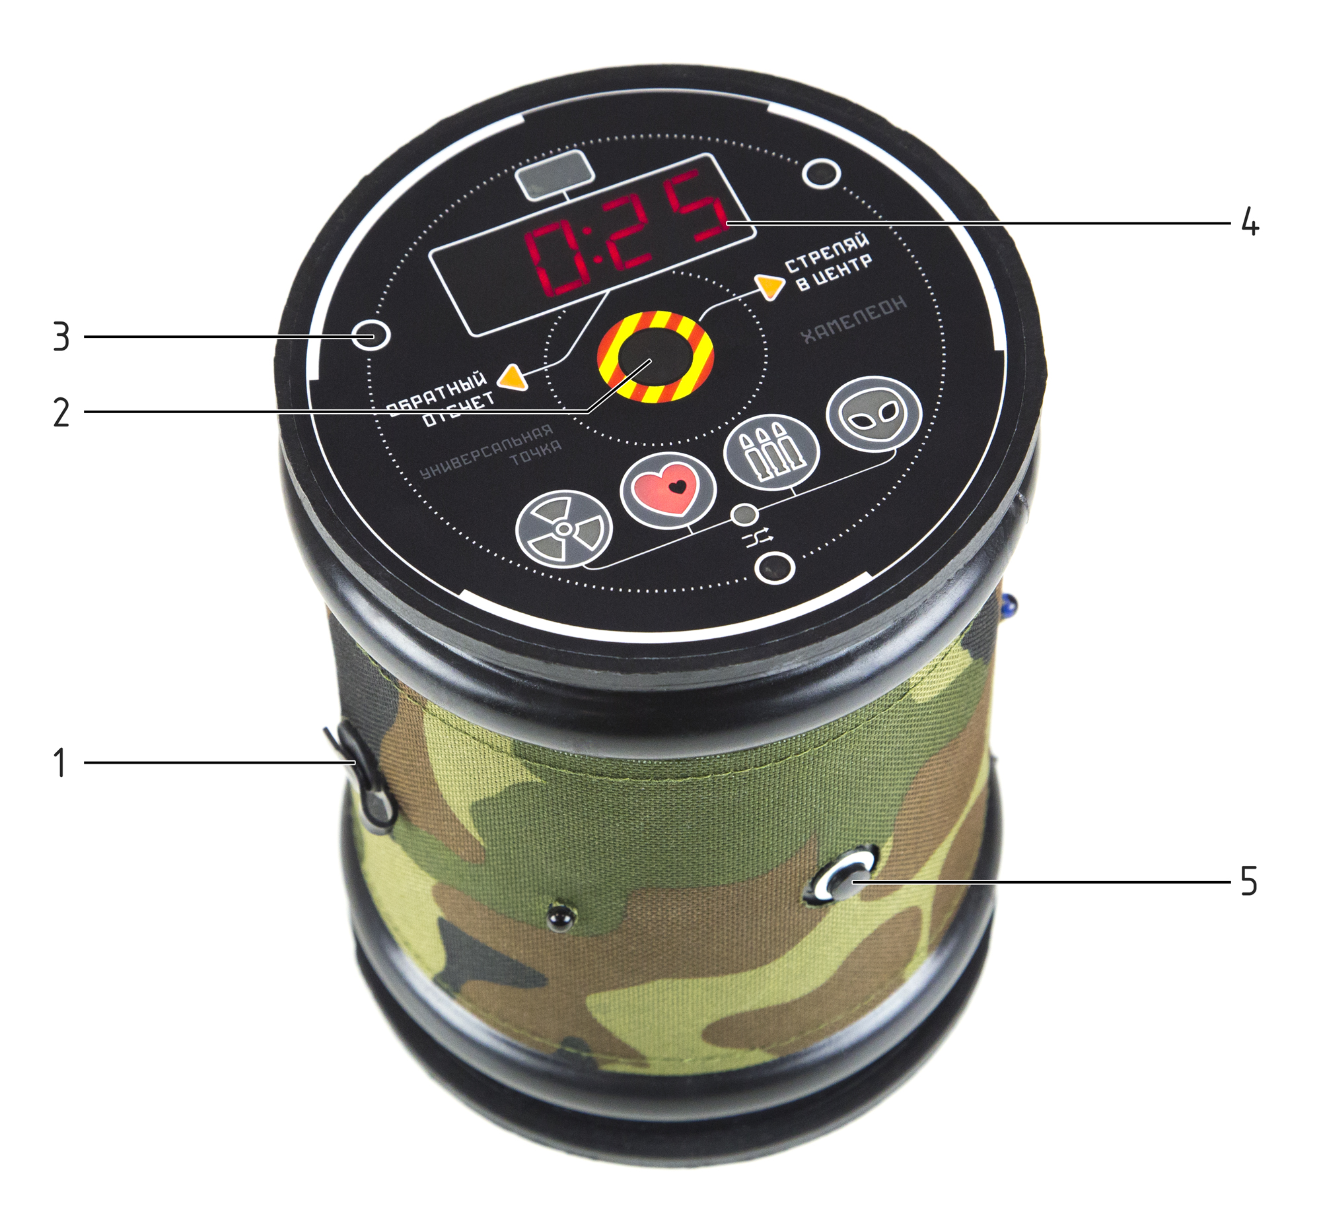

1 – charger inlet
2 – infrared sensor
3 – infrared diodes
4 – digital display
5 – control button

The equipment must be stored in a well ventilated room at a temperature of +18°С to +30°С and air humidity 45% to 65%.
You must make sure that the equipment is charged before storing it (at the nominal voltage of the accumulator).
- Warrantee promise
The manufacturer guarantees reliability of the LASERWAR individual set provided the user complies with all the product use requirements. The manufacturer promises to replace or repair an individual set of equipment provided the user complies with the transportation, storage and operation instructions and pays for the delivery of the faulty equipment to the city of Smolensk.
The warrantee cover for battery chargers, speakers, infrared modules is 14 DAYS.
ATTENTION! If the battery is used incorrectly (wrong battery charger is used to charge the equipment), the accumulators will not be covered by the warrantee!

Visit our website www.laserwar.com to obtain the full version of the user’s manual for LASERWAR equipment.

5
8
6
7
  - Changing tactical and technical
characteristics of the device

To set up the Chameleon universal point enter the admin mode. To do this, turn on the device by pushing and holding the control button.
All the settings are selected using same button. There are 3 types of scenarios available to players. There are several parameters that need to be chosen to set them up. The main configuration principle: parameters are chosen one by one in scenario settings. To move on to the next parameter, push and hold the control button for over 3 seconds. After a 5 second pause the device switches over to editing the scenario numerical order. After 10 seconds the changed data will be saved in the device memory and the universal point will notify about this by a short beep.
The set-up can also be done by a LASERWAR laser tag configurator.

  - Activating the device
As you turn the key and activate the universal point you will hear a sound signal. A scenario numerical order will appear on a digital display. You can launch a game by the control button or any LASERWAR remote. The pattern of a game will depend on the scenario selected.

5. Using your device

1. Weather conditions. We strongly recommend that you do not use the equipment in rainy weather and at a temperature below -20°С. Make sure no liquids get inside of the item. If this happens, stop operating the device and allow it to get dry at room temperature for at least 2 hours.
You should never charge the equipment that has been exposed to low temperatures. You should allow the electronic equipment to warm up at room temperature, and allow the condensation, produced due to sudden weather conditions change, to evaporate.
2. Accumulators. The CHAMELEON universal point play set has an integrated lithium-ion accumulator. Only Li+ battery chargers must be used to charge the device.
You must connect the charger to the device first, then to the mains.
There is a special indicator on the charger, which helps to control the charging process. If the accumulator is uncharged the light diode glows red. When the device is fully charged the colour changes to green.
Attention! Guns must be recharged immediately after use under constant supervision at a temperature above 0°С for a maximum of 2 hours.

